**Procedural Language /SQL**

**Exercise 1: Control Structures**

**Scenario 1:** The bank wants to apply a discount to loan interest rates for customers above 60 years old.

**Question:** Write a PL/SQL block that loops through all customers, checks their age, and if they are above 60, apply a 1% discount to their current loan interest rates.

DECLARE

v_age NUMBER;

v_original_rate NUMBER;

v_new_rate NUMBER;

BEGIN

DBMS_OUTPUT.PUT_LINE(

RPAD('Status', 18) ||

RPAD('Customer Name', 20) ||

RPAD('Loan ID', 10) ||

RPAD('Age', 6) ||

RPAD('Old Rate', 12) ||

RPAD('New Rate', 10)

);

FOR cust_rec IN (

SELECT

c.CustomerID,

c.Name AS CustomerName,

c.DOB,

l.LoanID,

l.InterestRate

FROM Customers c

JOIN Loans l ON c.CustomerID = l.CustomerID

) LOOP

v_age := TRUNC(MONTHS_BETWEEN(SYSDATE, cust_rec.DOB) / 12);

v_original_rate := cust_rec.InterestRate;

IF v_age > 60 THEN

v_new_rate := v_original_rate - (v_original_rate * 0.01);

UPDATE Loans

SET InterestRate = v_new_rate

WHERE LoanID = cust_rec.LoanID;

DBMS_OUTPUT.PUT_LINE(

RPAD('Discount Applied', 18) ||

RPAD(cust_rec.CustomerName, 20) ||

RPAD(cust_rec.LoanID, 10) ||

RPAD(v_age, 6) ||

RPAD(TO_CHAR(v_original_rate, '90.00') || '%', 10) ||

TO_CHAR(v_new_rate, '90.00') || '%'

);

ELSE

DBMS_OUTPUT.PUT_LINE(

RPAD('No Discount', 18) ||

RPAD(cust_rec.CustomerName, 20) ||

RPAD(cust_rec.LoanID, 10) ||

RPAD(v_age, 6) ||

RPAD(TO_CHAR(v_original_rate, '90.00') || '%', 10)

);

END IF;

END LOOP;

END;

/

**Output:**

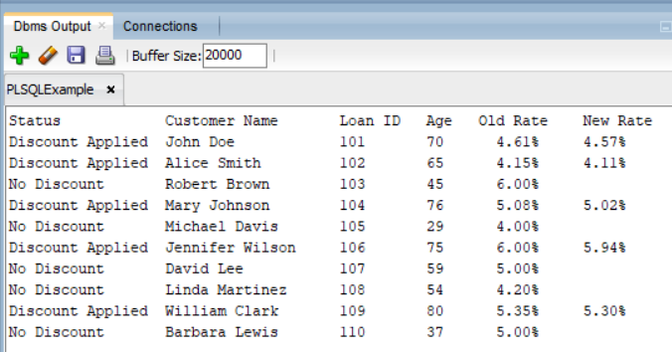

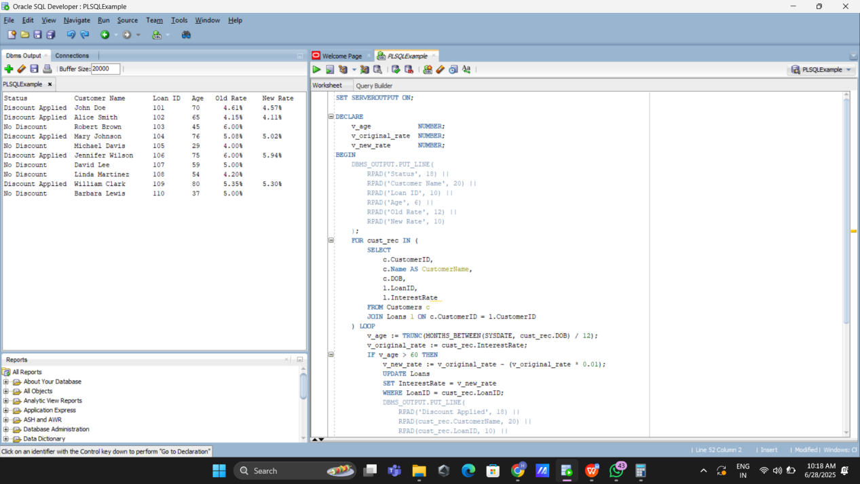

**_____________________________________________________________________**

**Scenario 2:** A customer can be promoted to VIP status based on their balance.

**Question:** Write a PL/SQL block that iterates through all customers and sets a flag IsVIP to TRUE for those with a balance over $10,000.

SET SERVEROUTPUT ON;

ALTER TABLE Customers ADD IsVIP VARCHAR2(5);

BEGIN

DBMS_OUTPUT.PUT_LINE(

RPAD('Customer ID', 15) ||

RPAD('Balance', 15) ||

RPAD('VIP Status', 15)

);

DBMS_OUTPUT.PUT_LINE(RPAD('-', 45, '-'));

FOR cust_rec IN (

SELECT CustomerID, Balance

FROM Customers

) LOOP

IF cust_rec.Balance > 10000 THEN

UPDATE Customers

SET IsVIP = 'TRUE'

WHERE CustomerID = cust_rec.CustomerID;

DBMS_OUTPUT.PUT_LINE(

RPAD(cust_rec.CustomerID, 15) ||

RPAD(TO_CHAR(cust_rec.Balance, '9999990.00'), 15) ||

'TRUE'

);

ELSE

UPDATE Customers

SET IsVIP = 'FALSE'

WHERE CustomerID = cust_rec.CustomerID;

DBMS_OUTPUT.PUT_LINE(

RPAD(cust_rec.CustomerID, 15) ||

RPAD(TO_CHAR(cust_rec.Balance, '9999990.00'), 15) ||

'FALSE'

);

END IF;

END LOOP;

COMMIT;

END;

/

**Output:**

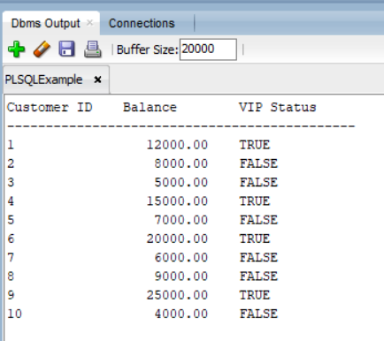

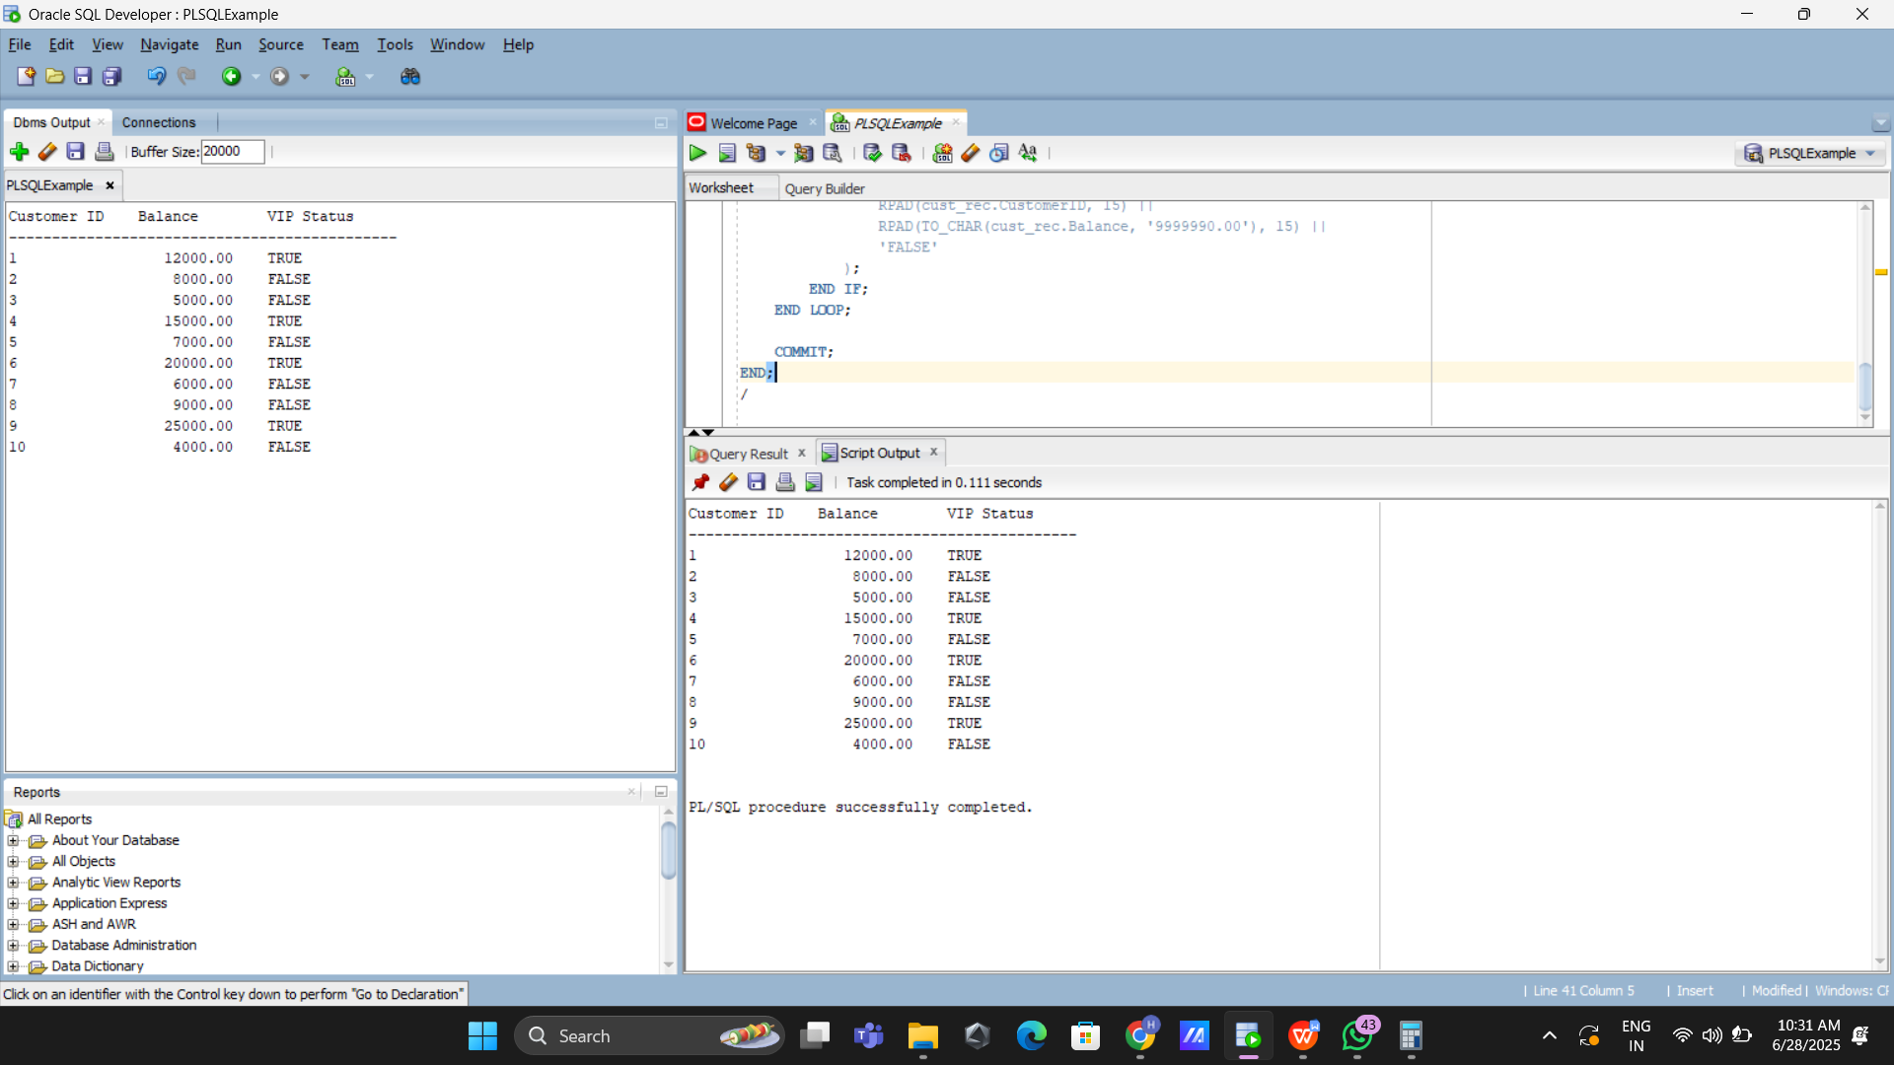

**Scenario 3:** The bank wants to send reminders to customers whose loans are due within the next 30 days.

**Question:** Write a PL/SQL block that fetches all loans due in the next 30 days and prints a reminder message for each customer.

SET SERVEROUTPUT ON;

DECLARE

v_count NUMBER := 0;

BEGIN

FOR loan_rec IN (

SELECT l.LoanID, c.Name AS CustomerName, c.CustomerID, l.EndDate

FROM Loans l

JOIN Customers c ON c.CustomerID = l.CustomerID

WHERE l.EndDate BETWEEN SYSDATE AND SYSDATE + 30

ORDER BY l.EndDate

) LOOP

v_count := v_count + 1;

DBMS_OUTPUT.PUT_LINE('Reminder: Dear ' || loan_rec.CustomerName || ',');

DBMS_OUTPUT.PUT_LINE('Your loan (Loan ID: ' || loan_rec.LoanID || ') is due for repayment on '||TO_CHAR(loan_rec.EndDate, 'FMMonth DD, YYYY')||'.');

DBMS_OUTPUT.PUT_LINE('Please ensure timely payment to avoid penalties.');

DBMS_OUTPUT.PUT_LINE(''); -- Blank line for separation

END LOOP;

IF v_count = 0 THEN

DBMS_OUTPUT.PUT_LINE('There are no loans due for repayment in the next 30 days.');

END IF;

END;

/

**Output:**

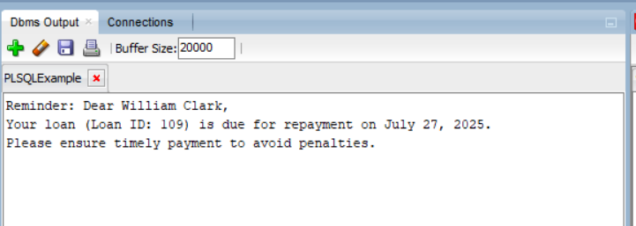

**Exercise 3: Stored Procedures**

**Scenario 1:** The bank needs to process monthly interest for all savings accounts.

**Question:** Write a stored procedure **ProcessMonthlyInterest** that calculates and updates the balance of all savings accounts by applying an interest rate of 1% to the current balance.

Set SERVEROUTPUT ON;

CREATE OR REPLACE PROCEDURE ProcessMonthlyInterest IS

v_old_balance NUMBER;

v_new_balance NUMBER;

v_savings_count NUMBER := 0;

v_skipped_count NUMBER := 0;

BEGIN

FOR acc_rec IN (

SELECT AccountID, CustomerID, AccountType, Balance

FROM Accounts

) LOOP

IF acc_rec.AccountType = 'Savings' THEN

v_old_balance := acc_rec.Balance;

v_new_balance := v_old_balance + (v_old_balance * 0.01);

UPDATE Accounts

SET Balance = v_new_balance,

LastModified = SYSDATE

WHERE AccountID = acc_rec.AccountID;

v_savings_count := v_savings_count + 1;

DBMS_OUTPUT.PUT_LINE('Account ID: ' || acc_rec.AccountID ||

' | Customer ID: ' || acc_rec.CustomerID ||

' | Type: ' || acc_rec.AccountType);

DBMS_OUTPUT.PUT_LINE('Old Balance: ' || TO_CHAR(v_old_balance, '9999990.00') ||

' | New Balance: ' || TO_CHAR(v_new_balance, '9999990.00'));

DBMS_OUTPUT.PUT_LINE('Status: Interest successfully applied');

DBMS_OUTPUT.PUT_LINE('');

ELSE

v_skipped_count := v_skipped_count + 1;

DBMS_OUTPUT.PUT_LINE('Account ID: ' || acc_rec.AccountID ||

' | Customer ID: ' || acc_rec.CustomerID ||

' | Type: ' || acc_rec.AccountType);

DBMS_OUTPUT.PUT_LINE('Old Balance: ' || TO_CHAR(acc_rec.Balance, '9999990.00') ||

' | New Balance: Not Applicable');

DBMS_OUTPUT.PUT_LINE('Status: Skipped - Not a savings account');

DBMS_OUTPUT.PUT_LINE('');

END IF;

END LOOP;

DBMS_OUTPUT.PUT_LINE(v_savings_count || ' savings account(s) updated.');

DBMS_OUTPUT.PUT_LINE(v_skipped_count || ' account(s) skipped.');

END;

/

BEGIN

PROCESSMONTHLYINTEREST;

END;

/

**OUTPUT:**

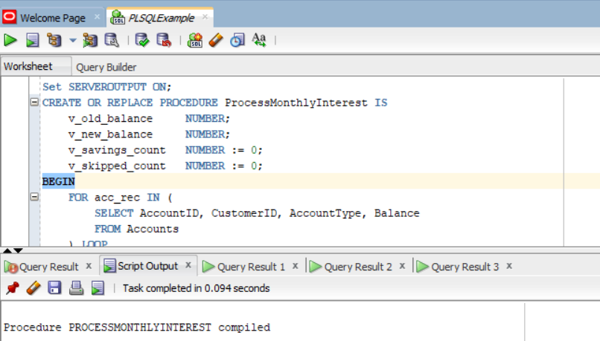

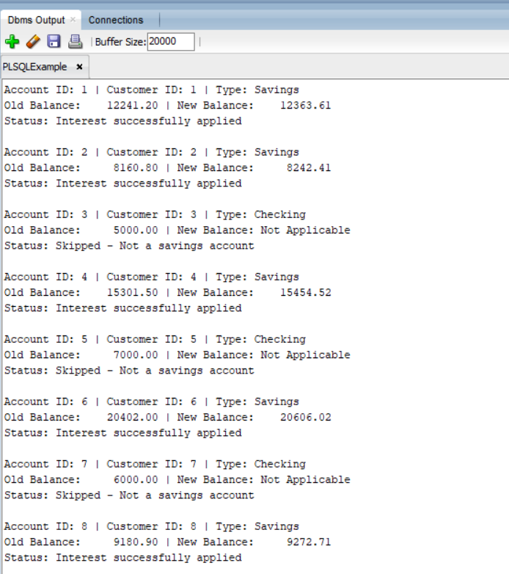

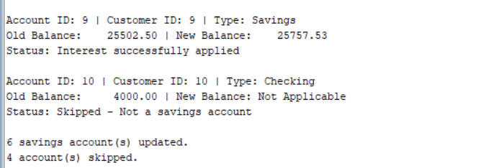

**Scenario 2:** The bank wants to implement a bonus scheme for employees based on their performance.

**Question:** Write a stored procedure **UpdateEmployeeBonus** that updates the salary of employees in a given department by adding a bonus percentage passed as a parameter.

Set SERVEROUTPUT ON;

CREATE OR REPLACE PROCEDURE UpdateEmployeeBonus(

p_Department IN VARCHAR2,

p_BonusPercent IN NUMBER

) IS

v_old_salary NUMBER;

v_new_salary NUMBER;

v_count NUMBER := 0;

BEGIN

FOR emp_rec IN (

SELECT EmployeeID, Name, Department, Salary

FROM Employees

WHERE Department = p_Department

) LOOP

v_old_salary := emp_rec.Salary;

v_new_salary := v_old_salary + (v_old_salary * p_BonusPercent / 100);

UPDATE Employees

SET Salary = v_new_salary

WHERE EmployeeID = emp_rec.EmployeeID;

v_count := v_count + 1;

DBMS_OUTPUT.PUT_LINE('Employee ID : ' || emp_rec.EmployeeID ||

' | Department: ' || emp_rec.Department);

DBMS_OUTPUT.PUT_LINE('Old Salary : ' || TO_CHAR(v_old_salary, '9999990.00') ||

' | New Salary: ' || TO_CHAR(v_new_salary, '9999990.00'));

DBMS_OUTPUT.PUT_LINE('Bonus Applied : ' || p_BonusPercent || '%');

DBMS_OUTPUT.PUT_LINE('');

END LOOP;

IF v_count = 0 THEN

DBMS_OUTPUT.PUT_LINE('No employees found in department "' || p_Department || '".');

ELSE

DBMS_OUTPUT.PUT_LINE(v_count || ' employee(s) in department "' || p_Department || '" received a ' || p_BonusPercent || '% bonus.');

END IF;

END;

/

BEGIN

UpdateEmployeeBonus('IT', 10); -- Apply 10% bonus to IT department

END;

/

**Output:**

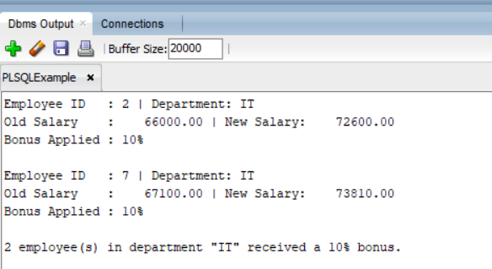

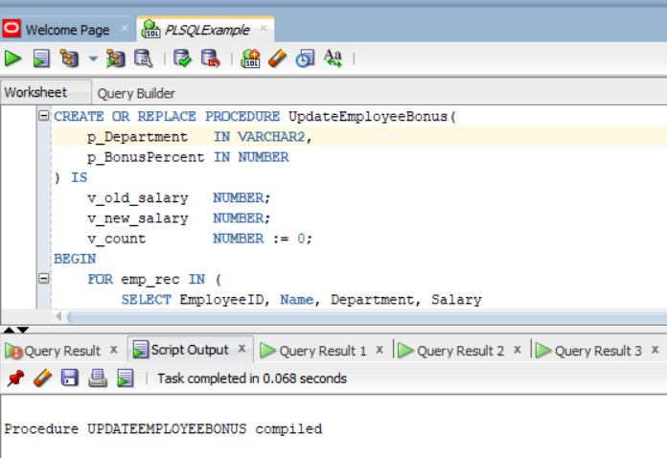

**Scenario 3:** Customers should be able to transfer funds between their accounts.

**Question:** Write a stored procedure **TransferFunds** that transfers a specified amount from one account to another, checking that the source account has sufficient balance before making the transfer.

SET SERVEROUTPUT ON;

CREATE OR REPLACE PROCEDURE TransferFunds(

p_source_account_id IN NUMBER,

p_destination_account_id IN NUMBER,

p_amount IN NUMBER

) IS

v_source_balance_before NUMBER;

v_destination_balance_before NUMBER;

v_source_balance_after NUMBER;

v_destination_balance_after NUMBER;

BEGIN

IF p_source_account_id = p_destination_account_id THEN

RAISE_APPLICATION_ERROR(-20003, 'Source and destination accounts must be different.');

END IF;

SELECT Balance INTO v_source_balance_before

FROM Accounts

WHERE AccountID = p_source_account_id

FOR UPDATE;

SELECT Balance INTO v_destination_balance_before

FROM Accounts

WHERE AccountID = p_destination_account_id

FOR UPDATE;

IF v_source_balance_before < p_amount THEN

RAISE_APPLICATION_ERROR(-20001, 'Insufficient balance in the source account.');

END IF;

UPDATE Accounts

SET Balance = Balance - p_amount,

LastModified = SYSDATE

WHERE AccountID = p_source_account_id;

UPDATE Accounts

SET Balance = Balance + p_amount,

LastModified = SYSDATE

WHERE AccountID = p_destination_account_id;

SELECT Balance INTO v_source_balance_after

FROM Accounts

WHERE AccountID = p_source_account_id;

SELECT Balance INTO v_destination_balance_after

FROM Accounts

WHERE AccountID = p_destination_account_id;

COMMIT;

DBMS_OUTPUT.PUT_LINE('Funds Transfer Summary');

DBMS_OUTPUT.PUT_LINE('-----------------------------');

DBMS_OUTPUT.PUT_LINE('Amount Transferred : Rs. ' || p_amount);

DBMS_OUTPUT.PUT_LINE('Source Account ID : ' || p_source_account_id);

DBMS_OUTPUT.PUT_LINE(' - Before Transfer : Rs. ' || v_source_balance_before);

DBMS_OUTPUT.PUT_LINE(' - After Transfer : Rs. ' || v_source_balance_after);

DBMS_OUTPUT.PUT_LINE('Destination Account ID : ' || p_destination_account_id);

DBMS_OUTPUT.PUT_LINE(' - Before Transfer : Rs. ' || v_destination_balance_before);

DBMS_OUTPUT.PUT_LINE(' - After Transfer : Rs. ' || v_destination_balance_after);

DBMS_OUTPUT.PUT_LINE('Status : Transfer completed successfully');

DBMS_OUTPUT.PUT_LINE('-----------------------------');

EXCEPTION

WHEN NO_DATA_FOUND THEN

RAISE_APPLICATION_ERROR(-20002, 'One or both account IDs do not exist.');

WHEN OTHERS THEN

ROLLBACK;

RAISE;

END;

/

--Transfer done

BEGIN

TransferFunds(1, 2, 500);

END;

/

--Transfer not done- id doesn’t exists

BEGIN

TransferFunds(101,102, 500);

END;

/

**Output:**

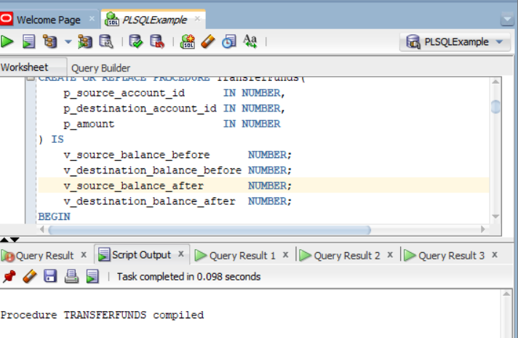

Source Account ID 1 and Destination Account ID 2 exists:

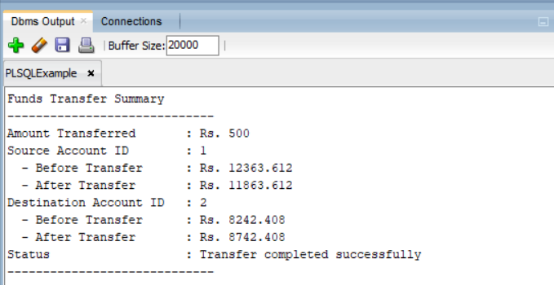

Source Account ID 101 and Destination Account ID 102 doesn’t exists:

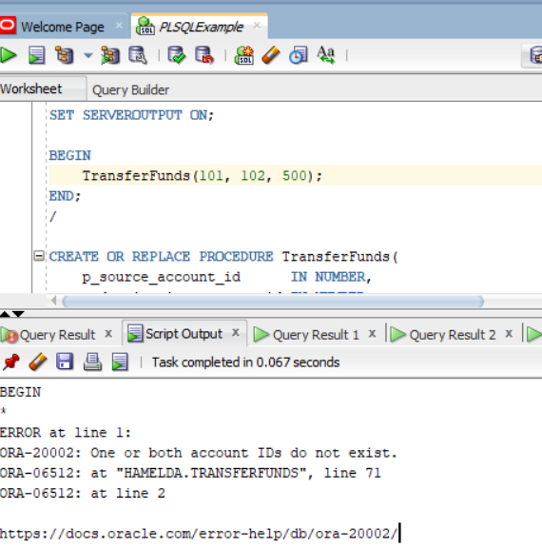

Customers data:

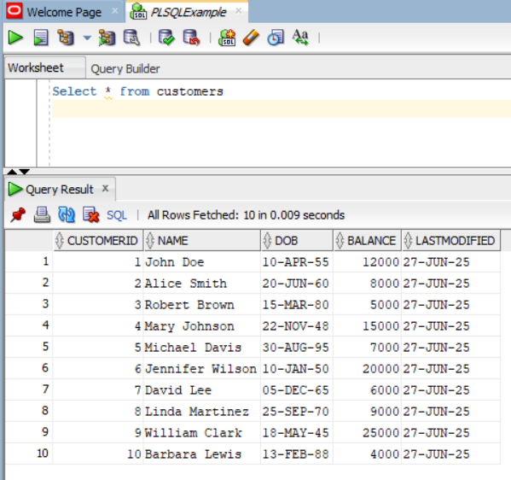

Loans data:

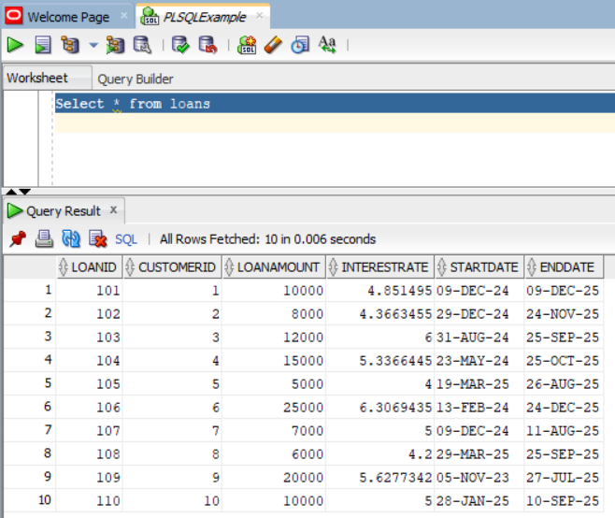

Employees data:

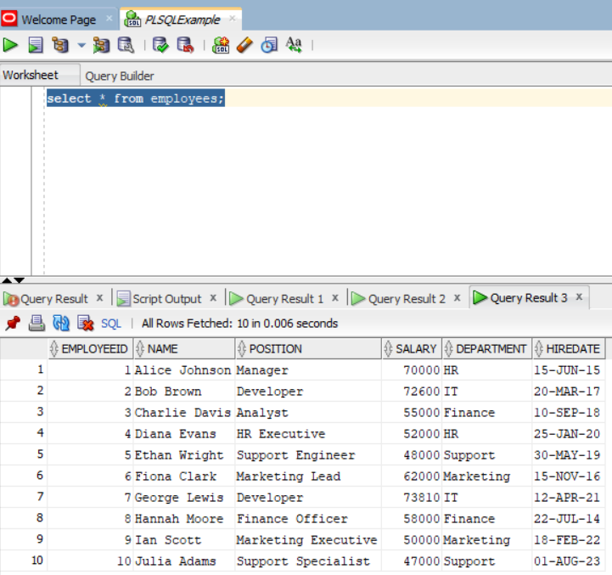

Accounts data:

